Seller First Name: Jose

Last Name: Cruz

Profile picture:

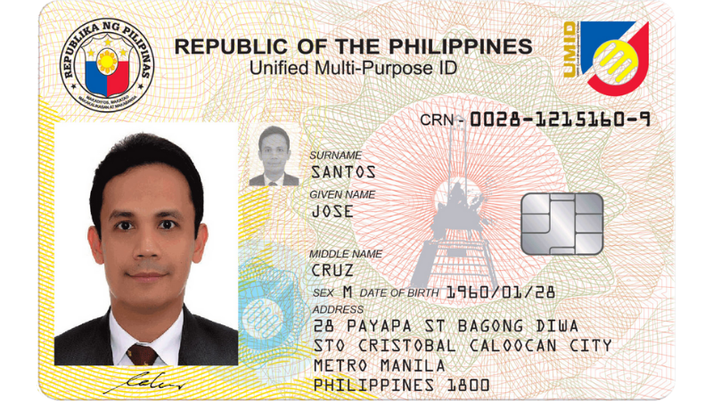

Valid Id:



Bussiness ID:

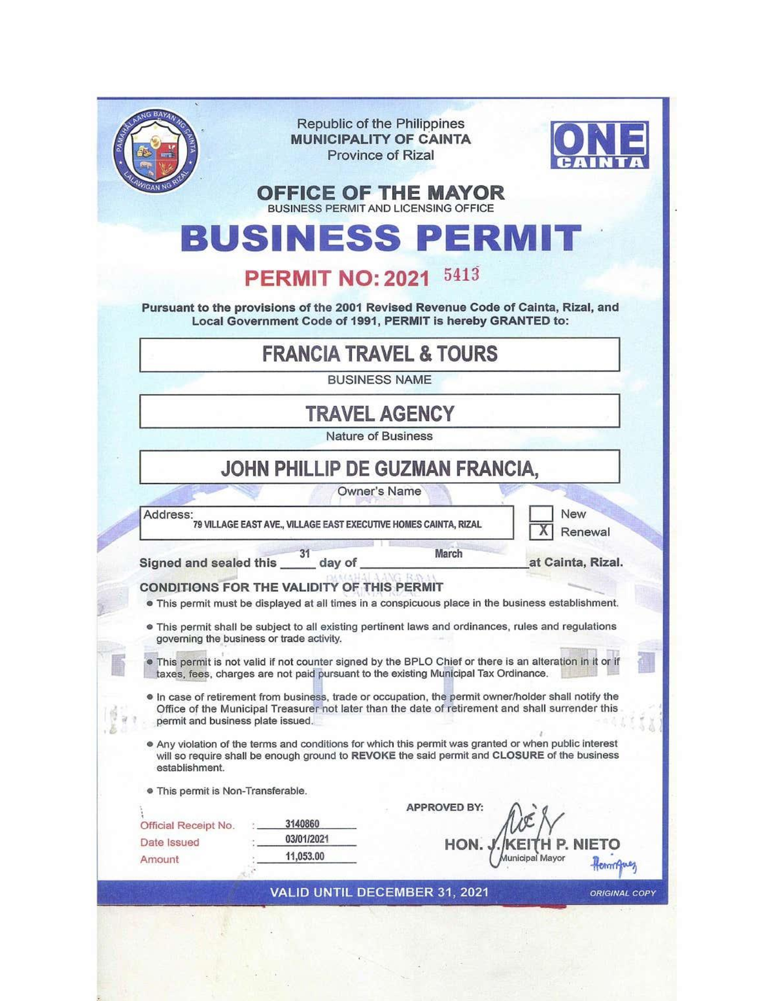

Contact #: 09055472333

Email: josecruz@gmail.com

Address: Asuncion, carmen, davao del norte

Name of the Store: JOSE POULTRY STORE

Availability time: 8AM - 7PM

Specific location of the address: drilon poultry farm, 8MWJ+WH9, Carmen, Davao del Norte

Pincode: 123123

Password: JoseStore123

Buyer First Name: Capate

Last Name: Yvette

Profile picture:

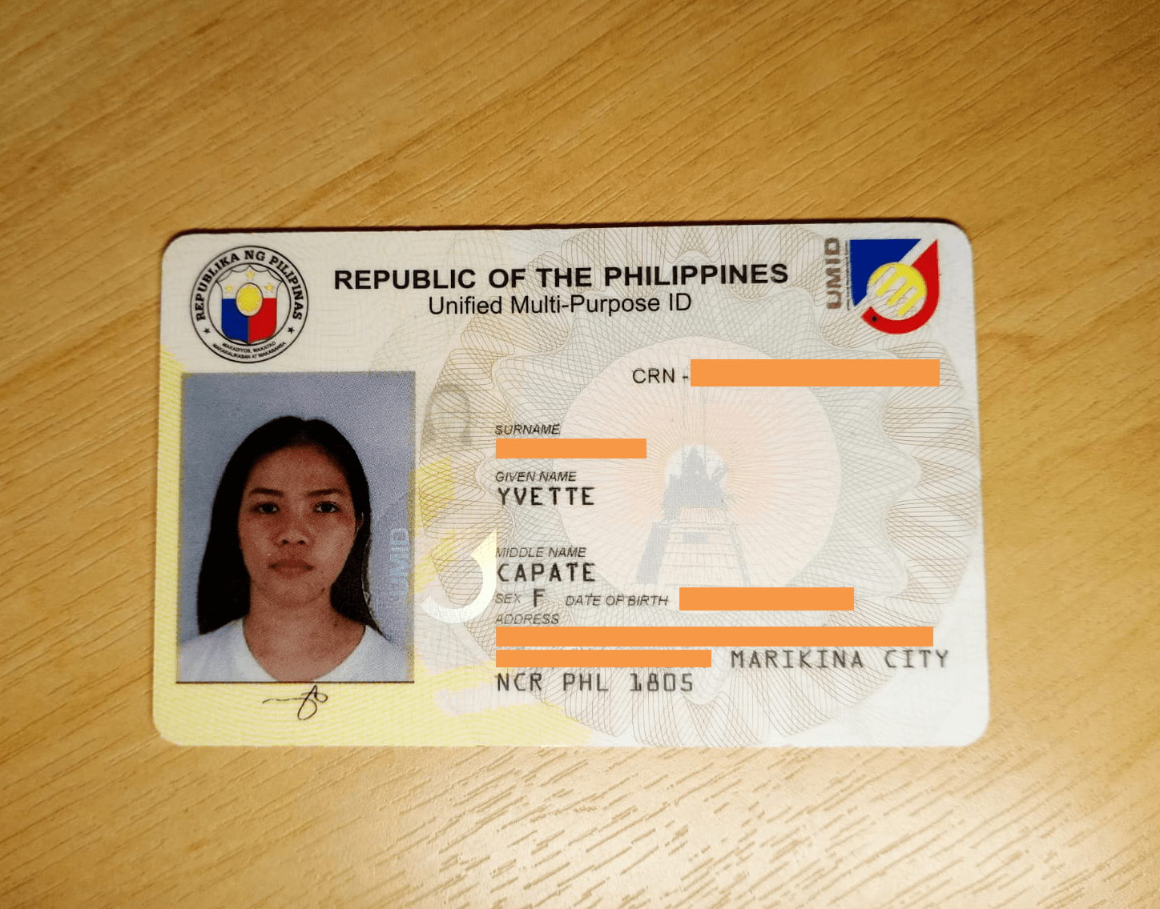

Valid Id:



Contact #: 09104033945

Email: yvettecapate@gmail.com

Address: Apokon, Tagum City

Preffered Specific location: Carmen, Davao del Norte

Preffered product type: Eggs

Preffered payment method: gcash

Password: Yvvtte123

Seller First Name: Juan

Last Name: Dela Cruz

Profile picture:

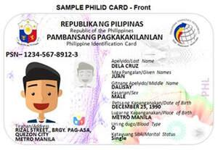

Valid Id:



Bussiness ID:



Contact #: 09276410375

Email: juandelacruz@gmail.com

Address: Santo Tomas, Davao del Norte

Name of the Store: kinamayan

Availability time: 9am - 10pm

Specific location of the address: Kinamayan, Santo Tomas, Davao del Norte

Pincode: 345345

Password: delaCruz345

Buyer First Name: JUANA

Last Name: MARTINEZ

Profile picture:



Valid Id:



Contact #: 09056596994

Email: juanamartinez@gmail.com

Address: Tibal-og, Santo Tomas, Davao del Norte

Preffered Specific location: Tibal-og, Santo Tomas, Davao del Norte

Preffered product type: vegetables

Preffered payment method: gcash

Password: JuaNa123

Seller First Name: Pedro

Last Name: Dela Cruz

Profile picture:

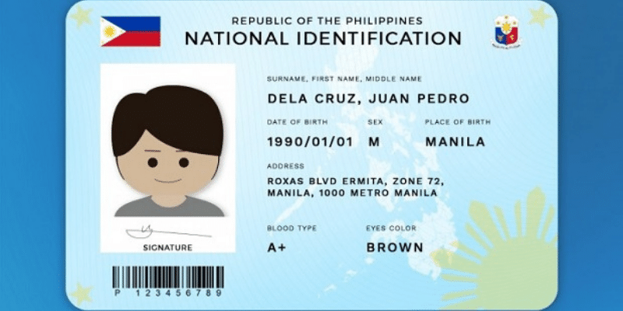

Valid Id:



Bussiness ID:



Contact #: 09550969351

Email: pedrodelacruz@gmail.com

Address: Masara, davao de oro

Name of the Store: gulayan ni pedro

Availability time: 6am-5pm

Specific location of the address: Masara, davao de oro

Pincode: 456456

Password: pEdro465

Buyer First Name: Arianne

Last Name: Timogan

Profile picture:



Valid Id:



Contact #: 09554723232

Email: ariannetimogan@gmail.com

Address: Rizal St., Tagum City, Davao del Norte

Preffered Specific location: Maco

Preffered product type: livestock

Preffered payment method: COD

Password: ARianne123

Seller First Name: JOHN

Last Name: VICENTE

Profile picture:



Valid Id:



Bussiness ID:



Contact #: 09472233055

Email: johnvicente@gmail.com

Address: Mawab

Name of the Store: Fresh gulay

Availability time: 8am-3pm

Specific location of the address: Mawab, davao del norte

Pincode: 678678

Password: vicenTe678

Buyer First Name: Maria

Last Name: Sanchez

Profile picture:

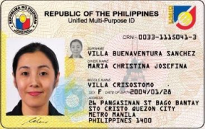

Valid Id:



Contact #: 09884554657

Email: mariasanchez@gmail.com

Address: Andili, Mawab, Davao de Oro

Preffered Specific location: MAWAB

Preffered product type: VEGETABLES

Preffered payment method: COD

Password:SAnchez675

Seller First Name: Florentino

Last Name: Floro

Profile picture:

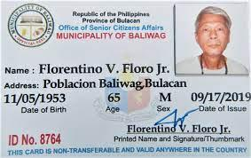

Valid Id:



Bussiness ID:



Contact #: 09369650860

Email: florentinofloro@gmail.com

Address: Tagum City

Name of the Store: banana plantation

Availability time: 5am-8pm

Specific location of the address: Hijo banana plantation, tagum city

Pincode: 789789

Password: Florentino789

Buyer First Name: ARTHUR

Last Name: TUGADE

Profile picture:



Valid Id:



Contact #: 09560147291

Email: arthurtugade@gmail.com

Address: maco, davao de oro

Preffered Specific location: tagum

Preffered product type: fruits

Preffered payment method: COD

Password: TuGade67

**Seller** First Name: Miguel

Last Name: Santos

Profile picture:



Valid Id: 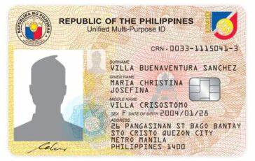

Bussiness ID/Permit: 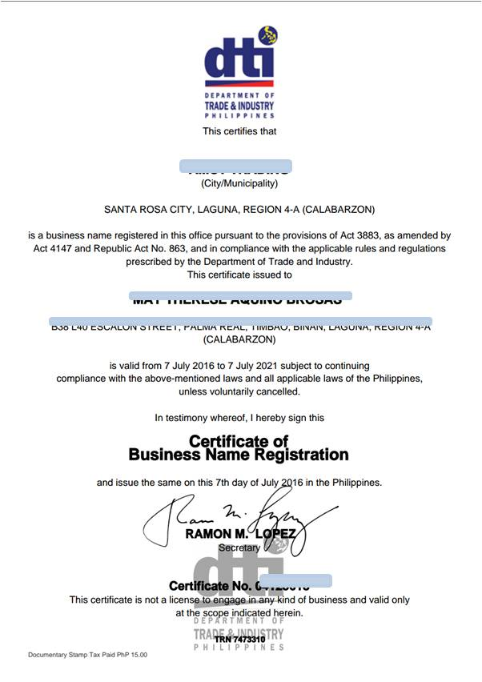

Contact #: 09123456789

Email: Address: miguelsantos@gmail.com

Name of the Store: PinoyMart

Availability time: 7:00 AM- 7:00 PM

Specific location of the address: Purok 6-B, Apokon, Tagum City, Davao Del Norte

Pincode/GcashNumber: 09123456789 - Miguel Santos

Password: PinoyPride123!

**Buyer** First Name: Maria Teresa

Last Name: Dela Cruz

Profile picture:



Valid Id:

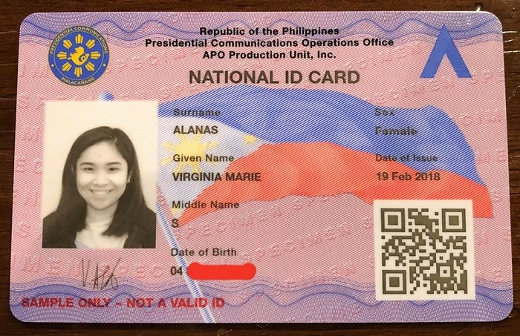

Contact #: 09176543210

Email: mariacruz@example.com

Address: Bonifacio Street, Barangay Poblacion,Tagum City, Davao del Norte

Philippines

Preffered Specific location: Tagum

Preffered product type: Crops

Preffered payment method: Online Payment : GCash

Password: SalamatPo456!

Seller First Name: Anna Mae

Last Name: Reyes

Profile picture:

Valid Id:

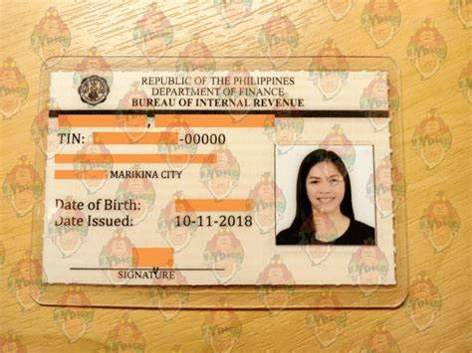

Bussiness ID/Permit: 

Contact #: 09228765432

Email: Address: annareyes@gmail.com

Name of the Store: PinasPantry

Availability time: 7:00 AM- 7:00 PM

Specific location of the address: Purok 5- San Isidro, La filipina, Tagum City Davao Del Norte

Pincode/Gcash Num.: 09228765432 - Anna Reyes:

Password: BaryaLang123!

Buyer First Name: Juan Macho

Last Name: Dela Cruz

Profile picture: 

Valid Id:

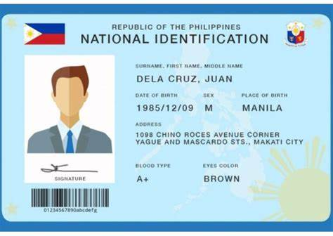

Contact #: 09201234567

Email: juandelacruz@gmail.com

Address: Mankilam, Tagum City, Davao del Norte

Preffered Specific location: Tagum

Preffered product type: Crops

Preffered payment method: COD, GCash

Password: Mabuhay789!

Seller First Name: Sofia

Last Name: Lim

Profile picture:



Valid Id:

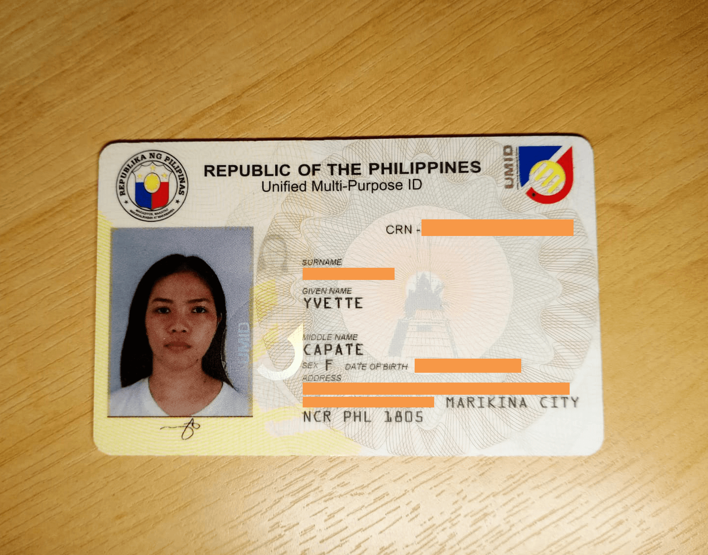

Bussiness ID:

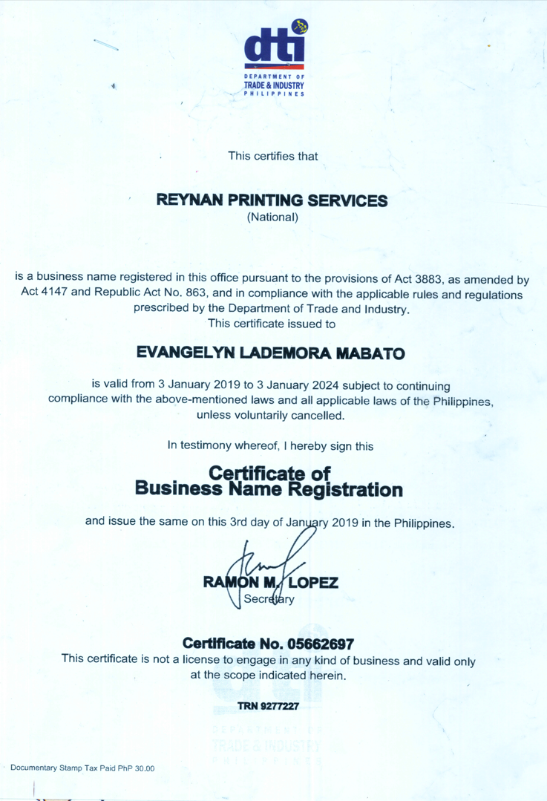

Contact #: 09178901234

Email: Address: sofialim@example.com

Name of the Store: SariSariSquad

Availability time: 7:00 AM- 9:00 PM

Specific location of the address:National Highway, Magugpo West, Tagum City, Davao del Norte

Pincode/Gcash Number: :09178901234 - Sofia Lim

Password: Fiesta456!

Buyer First Name: Carlo

Last Name: Garcia

Profile picture:



Valid Id: 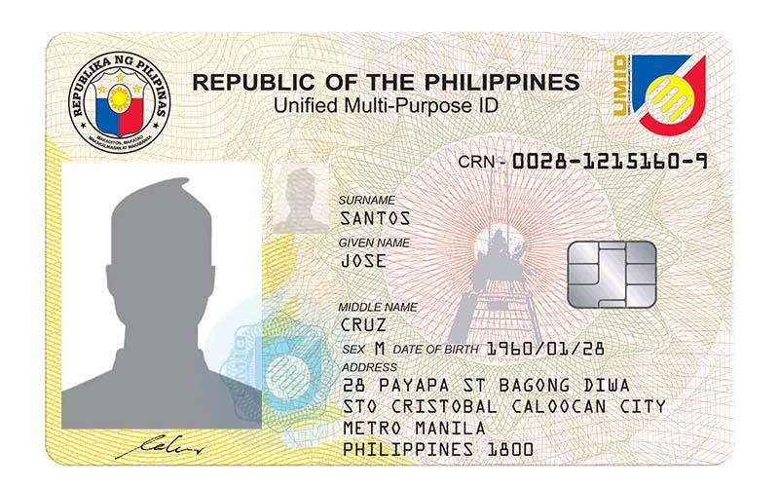

Contact #: 09256789012

Email: carlogarcia@gmail.com

Address: Purok Sampaguita, Magugpo West, Tagum City, Davao Del Norte

Preffered Specific location: Tagum

Preffered product type: Crops

Preffered payment method: COD

Password: Sampaguita987!

Seller First Name: Marie

Last Name: Cubar

Profile picture: 

Valid Id:



Bussiness ID/Permit:



Contact #: 09182345678

Email: Address: mariecubar@gmail.com

Name of the Store: BentaBuddy

Availability time: 7:00 AM- 9:00 PM

Specific location of the address: Quezon Street, Tagum City, Davao del Norte

Pincode: 09182345678 - Marie Cubar

Password: Palengke789!

Buyer First Name: Eduardo

Last Name: Reyes

Profile picture: 

Valid Id:



Contact #: 09273456789

Email: eduardoreyes@gmail.com

Address: Brgy. Baluno, Tagum City, Davao del Norte

Preffered Specific location: Tagum

Preffered product type: Livestocks, Crops

Preffered payment method: COD

Password: Bayanihan123!

Seller First Name: Grace

Last Name: Fernandez

Profile picture:



Valid Id:



Bussiness ID: 

Contact #: 09194567890

Email: Address: gracefernandez@gmail.com

Name of the Store: TindahanNiGrace

Availability time: 7:00 AM- 8:00 PM

Specific location of the address: National Highway, Magugpo West, Tagum City, Davao del Norte

Pincode: 09194567890 - Grace Fernandez

Password: Barangay123!

Buyer First Name: Melbert

Last Name: Diaz

Profile picture:

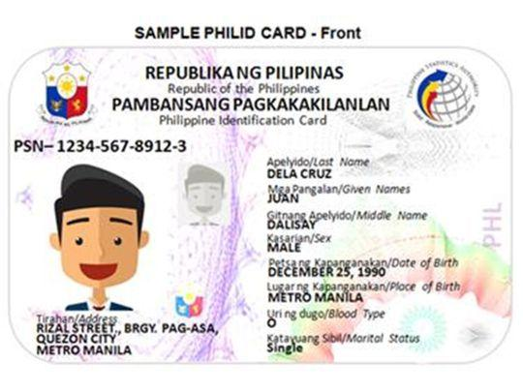

Valid Id:



Contact #: 09265678901

Email: melbertdiaz@gmail.com

Address: Pioneer Avenue, Magugpo East, Tagum City, Davao del Norte

Preffered Specific location: Tagum City

Preffered product type: Crops

Preffered payment method: COD

Password: Pasalubong456!